Resize the document to fit your screen using the zoom function on the menu above.
Learning framework |  |  |  |  |  |  |  |  |  |  |  |  | 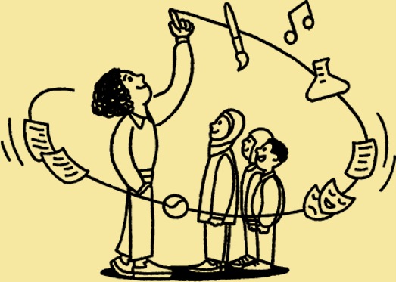
Our learning framework is an evidence-informed model of learning. We use it at Oak to guide and inform our design of lessons.

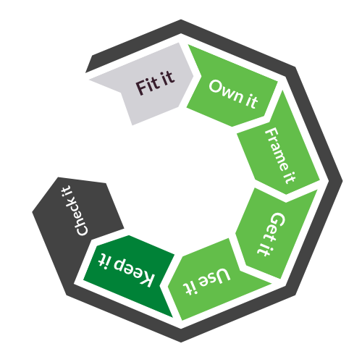
Adapted from McCrea, P. Developing Expert Teaching (2023)
- The learning framework pulls together all the composite parts required for anyone to learn something into a useful sequence.

- ‘It’ refers to the piece of new knowledge and these 7 stages are necessary for learning to happen effectively. Without any one of these stages, there is a risk that no learning happens.

- The learning framework does not span a lesson but a much longer period of time.

- Fit it happens before learning starts, Own it, Frame it, Get it and Use it happen within a lesson, and Check it happens throughout.

Stages |  |  |  |  |  | Description |  |  |  |  |  |  |  |  |  |  |  | Features of Oak curricula and lessons
Fit it |  |  |  | 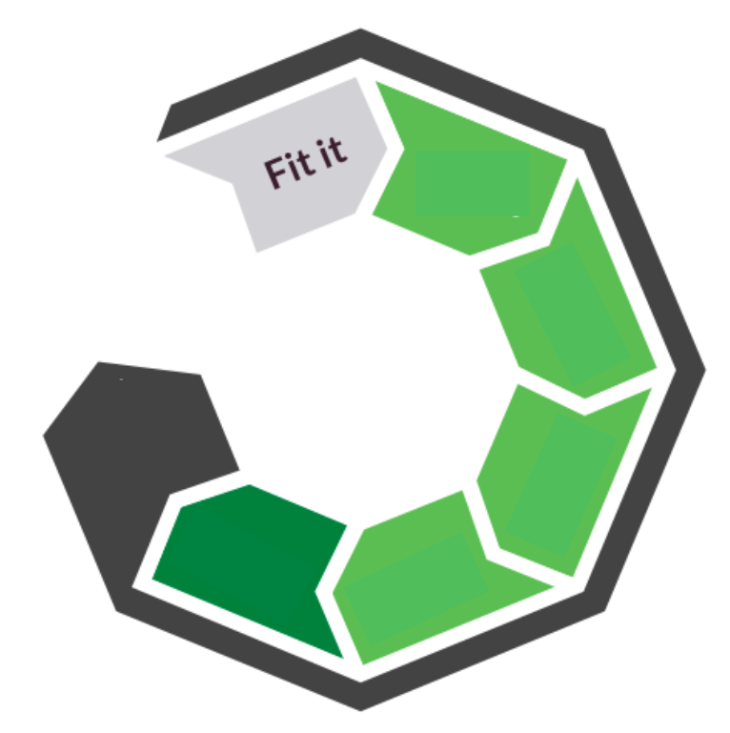 |  | Ensuring pupils are learning the right knowledge.  Learning needs to be fitted to the pupil. This stage is undertaken by the teacher with the support of our resources. This is where a teacher might identify what is the next thing that pupils need to learn, based on what they already know. |  |  |  |  |  |  |  |  |  |  |  | - Curriculum sequence and curriculum information  - Unit and lesson information on the website
Own it |  |  |  | 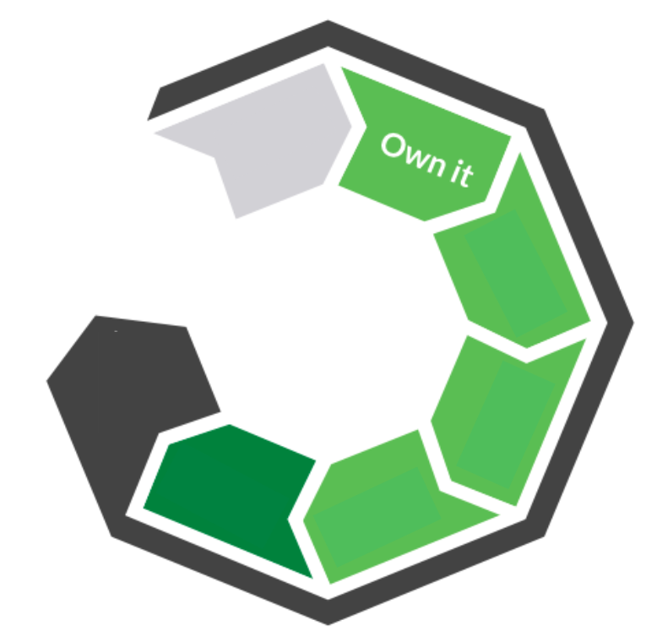 |  | Ensuring pupils are motivated to learn.  This is what teachers do to help pupils own their learning. Teachers do this by purposefully planning to build motivation at the start of a lesson and two effective techniques are through engineering success and piquing their interest.  We need motivation because we pay attention to things we are motivated to do and that we see the value in. If pupils are not motivated they are unlikely to pay attention. If they’re not paying attention they will not learn.  The impact of poor motivation is compound. The Matthew effect takes its name from a passage in the Bible: to those that have, more shall be given and for those who have nothing, what little they have will be taken away. Pupils who experience success when learning are likely to spend more and more time doing it, getting better and better, while those who find it more difficult come to believe that it is not for them. |  |  |  |  |  |  |  |  |  |  |  | - Prior knowledge starter quiz  - Motivational nudges through teacher visibility, enthusiasm & informal tone and motivational language in the video  - Accessibility measures including user experience on the web
Frame it |  |  |  |  |  | Ensuring pupils build on and link to existing knowledge.  New knowledge needs to be built on prior knowledge as we make sense of new knowledge by making connections with what we already know. This is like building a wall where each brick represents a new piece of knowledge built upon what has been laid prior. If bricks are missing due to absence or poor quality teaching, it becomes impossible to build upon and the gap gets bigger.  Learning works in the same way. If new knowledge is too far removed from what we already know, we won’t understand it. We have to prime pupils by getting them to bring to mind what they already know and link this to the new knowledge we want them to learn. |  |  |  |  |  |  |  |  |  |  |  | - Prior knowledge starter quiz  - Verbal explanation linking new learning to prior learning
Get it |  |  |  |  |  | Helping pupils to understand the knowledge.  Helping pupils understand new knowledge draws on the pedagogical strategy of explanation. The knowledge will be broken down into manageable chunks and is then explained with the support of techniques such as modelling and analogy. It’s important that teachers get pupils to think hard about the new knowledge and make meaningful connections. |  |  |  |  |  |  |  |  |  |  |  | - Explicit explanation phases in lessons  - Modelling
Use it |  |  |  |  |  | Ensuring pupils practise application of the knowledge.  This is commonly referred to as practice whereby a pupil puts their new learning to use. |  |  |  |  |  |  |  |  |  |  |  | - Explicit practice phases  - Quizzing
Keep it |  |  |  |  |  | Ensuring the knowledge sticks.  Learning happens over time, and the most effective learning takes months to stick. Keep it is why our model of learning goes beyond single lessons as successful learning takes much longer to secure.  There is a feature in our memory called interference, which is the process of forgetting that occurs naturally as time passes and is modelled on the curve below.  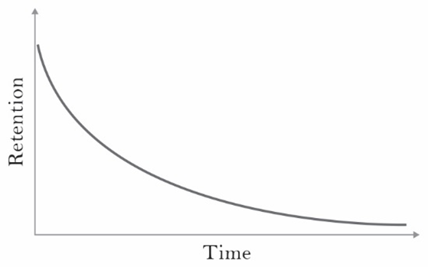  © Making Every Maths Lesson Count, 2019  Exact figures are disputed but it is suggested that only 50% of new knowledge we may have been taught is remembered after one hour, falling to 20% after a week. Pupils will forget what has been taught if we don’t deliberately provide opportunities to recall prior learning.  Observing what happens as pupils revisit knowledge is illustrated below. It shows the progressive retention as new learning is reintroduced at deliberate intervals. The spacing between reintroductions gradually increases from the next day to three days later and so on.  Each time the pupil is required to retrieve the knowledge, the retention curve is boosted.  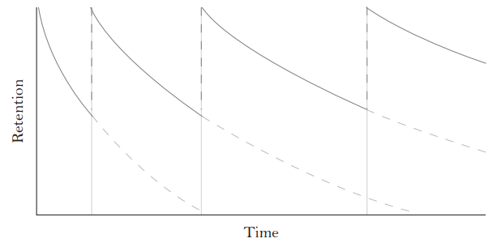  © Making Every Maths Lesson Count, 2019 |  |  |  |  |  |  |  |  |  |  |  | - Implicit retrieval throughout a unit  - Unit level quiz (pending)
Check it |  |  |  |  |  | Checking and course correcting throughout  The final part of the learning model is check it whereby teachers need to check pupils’ understanding. Examples of this are teachers asking questions to check understanding and responding to the information gained as a result. Another is pupils being provided with model responses to a task to compare their response against.  Crucially, check it happens alongside all of the other stages as indicated by the dark grey border enclosing the model. |  |  |  |  |  |  |  |  |  |  |  | - Prior knowledge starter quiz  - Checks for understanding  - Explicit feedback phases  - Lesson summary  - Model task responses  - Assessment exit quiz
✔ Example

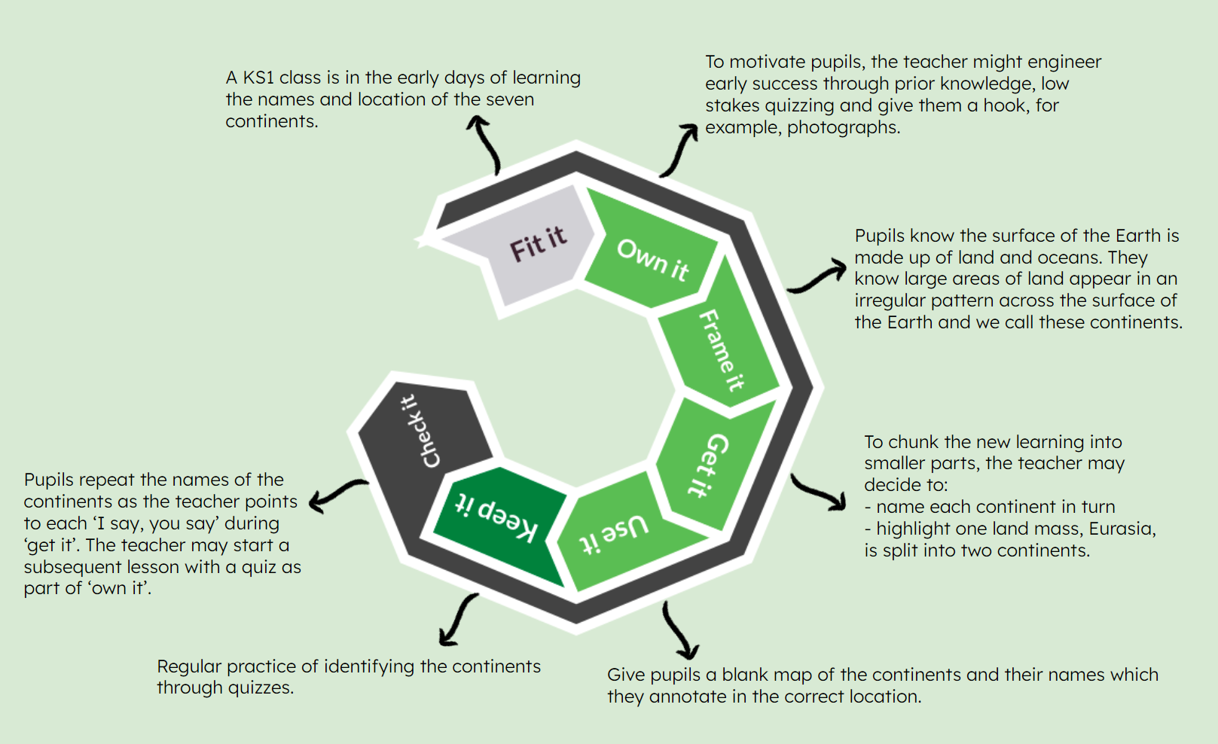

Summary

- The learning framework guides learning at Oak

- All stages are sequential in the learning process except check it, which happens throughout

- Not all stages occur during a lesson

- Should one of these stages be absent or poorly executed, learning is likely to be hampered

McCrea, P (in press). Expert teaching
Stanovich, 1986

